LAB Logbook

Lab 1
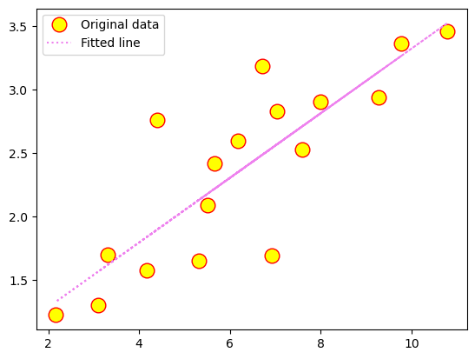
Lab 2
Test Accuracy: 0.901

Model: "sequential_1"
_________________________________________________________________
Layer (type) Output Shape Param #
=================================================================
dense_4 (Dense) (None, 64) 704

dense_5 (Dense) (None, 32) 2080

dense_6 (Dense) (None, 1) 33

=================================================================
Total params: 2817 (11.00 KB)
Trainable params: 2817 (11.00 KB)
Non-trainable params: 0 (0.00 Byte)
_________________________________________________________________
None
Model: "sequential_1"
_________________________________________________________________
Layer (type) Output Shape Param #
=================================================================
dense_4 (Dense) (None, 64) 704

dense_5 (Dense) (None, 32) 2080

dense_6 (Dense) (None, 1) 33

=================================================================
Total params: 2817 (11.00 KB)
Trainable params: 2817 (11.00 KB)
Non-trainable params: 0 (0.00 Byte)
_________________________________________________________________
None

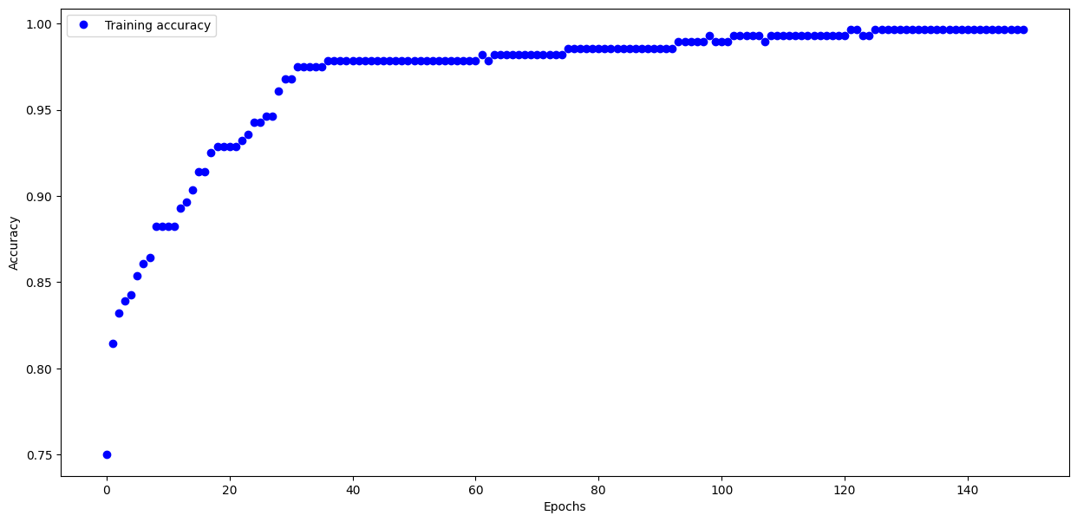
Task 2 :
O1 : 0.823
O2 : 0.823

Lab 3
Task 1:
313/313 - 0s - loss: 0.3622 - accuracy: 0.8799 - 211ms/epoch - 673us/step

Test accuracy: 0.8798999786376953

Task 2:
Model: "sequential"
_________________________________________________________________
Layer (type) Output Shape Param #
=================================================================
flatten (Flatten) (None, 784) 0

dense (Dense) (None, 69) 54165

dense_1 (Dense) (None, 96) 6720

dense_2 (Dense) (None, 129) 12513

dense_3 (Dense) (None, 229) 29770

dense_4 (Dense) (None, 329) 75670

dense_5 (Dense) (None, 12) 3960

=================================================================
Total params: 182798 (714.05 KB)
Trainable params: 182798 (714.05 KB)
Non-trainable params: 0 (0.00 Byte)
_________________________________________________________________

Lab 4
Task1: History of Losses after every Epoch
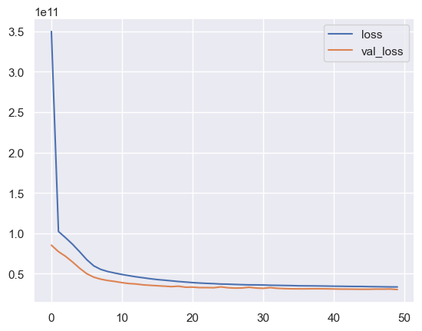
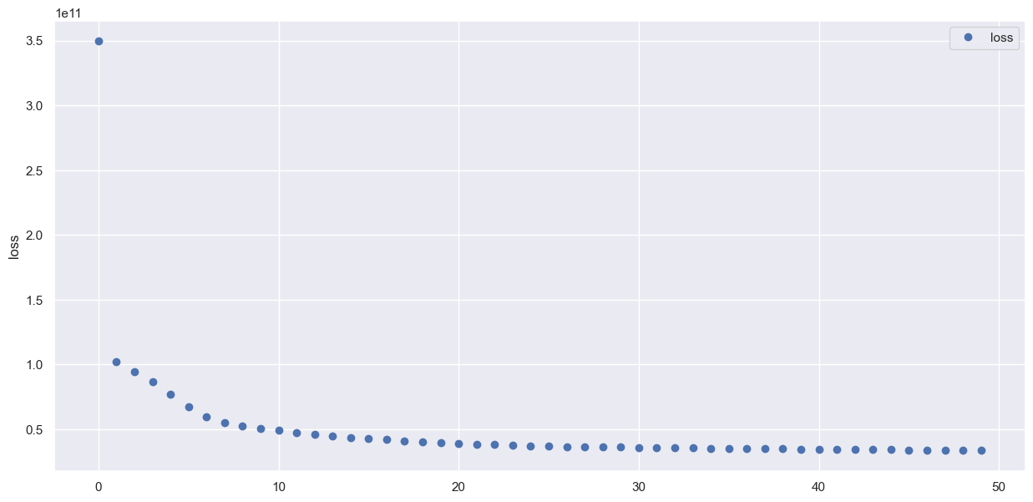

Task2: Model summary
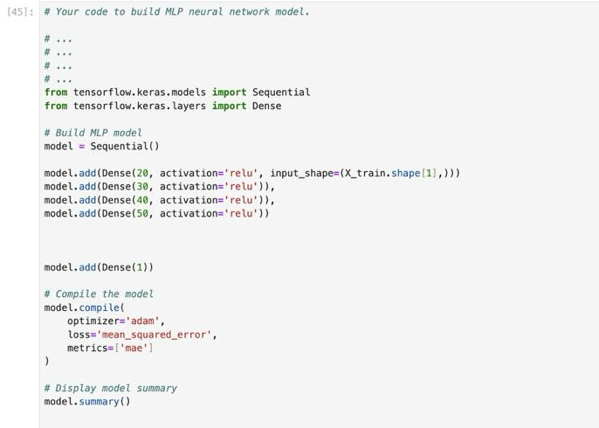

Model: "sequential"
_________________________________________________________________
Layer (type) Output Shape Param #
=================================================================
dense (Dense) (None, 20) 400

dense_1 (Dense) (None, 30) 630

dense_2 (Dense) (None, 40) 1240

dense_3 (Dense) (None, 50) 2050

dense_4 (Dense) (None, 1) 51

=================================================================
Total params: 4371 (17.07 KB)
Trainable params: 4371 (17.07 KB)
Non-trainable params: 0 (0.00 Byte)
_________________________________________________________________

Lab 5
Task1: Model building code and model summary.
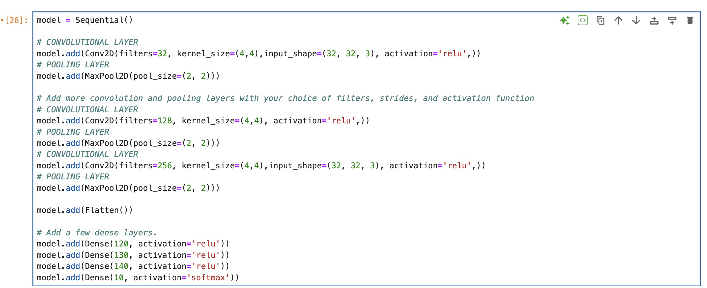
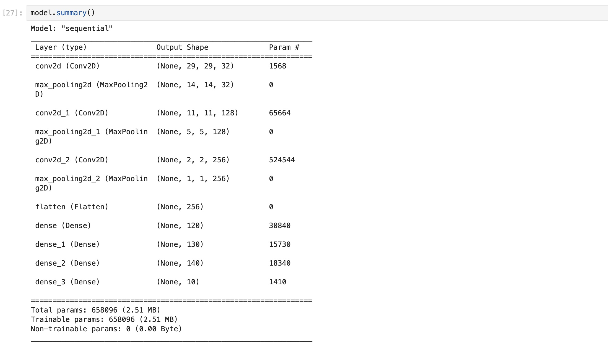

Task 2: Graphical representation depicting the train loss and validation loss trends (4 graphs)
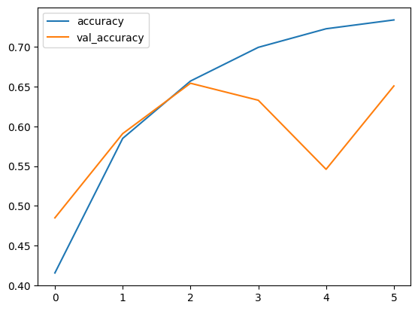

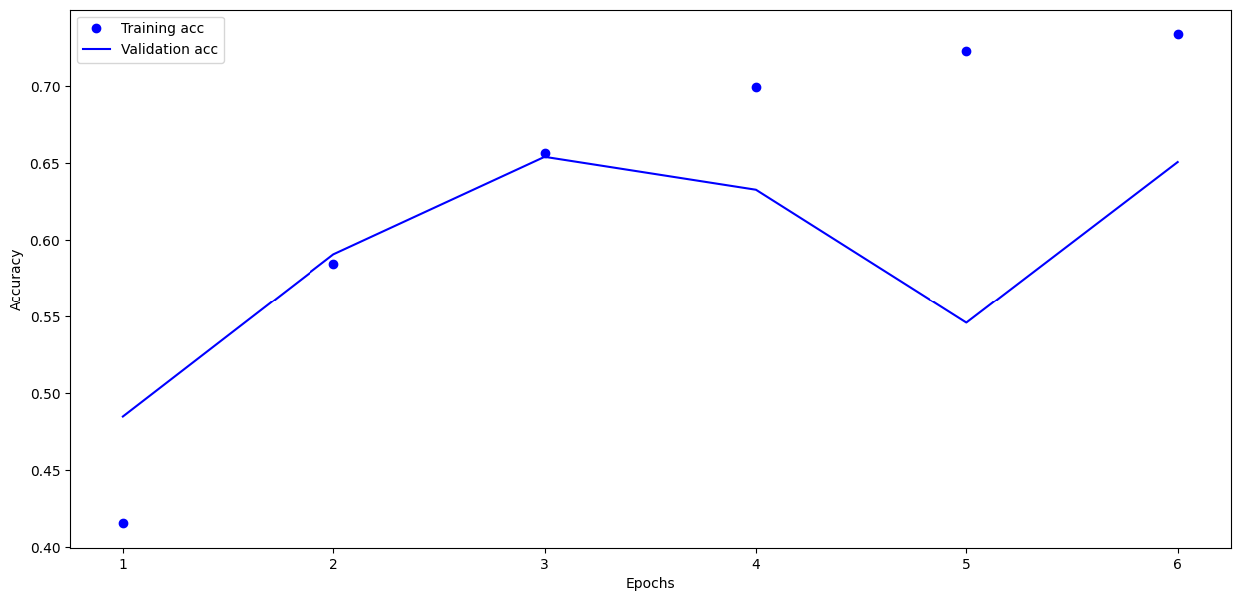



Lab 6
1.
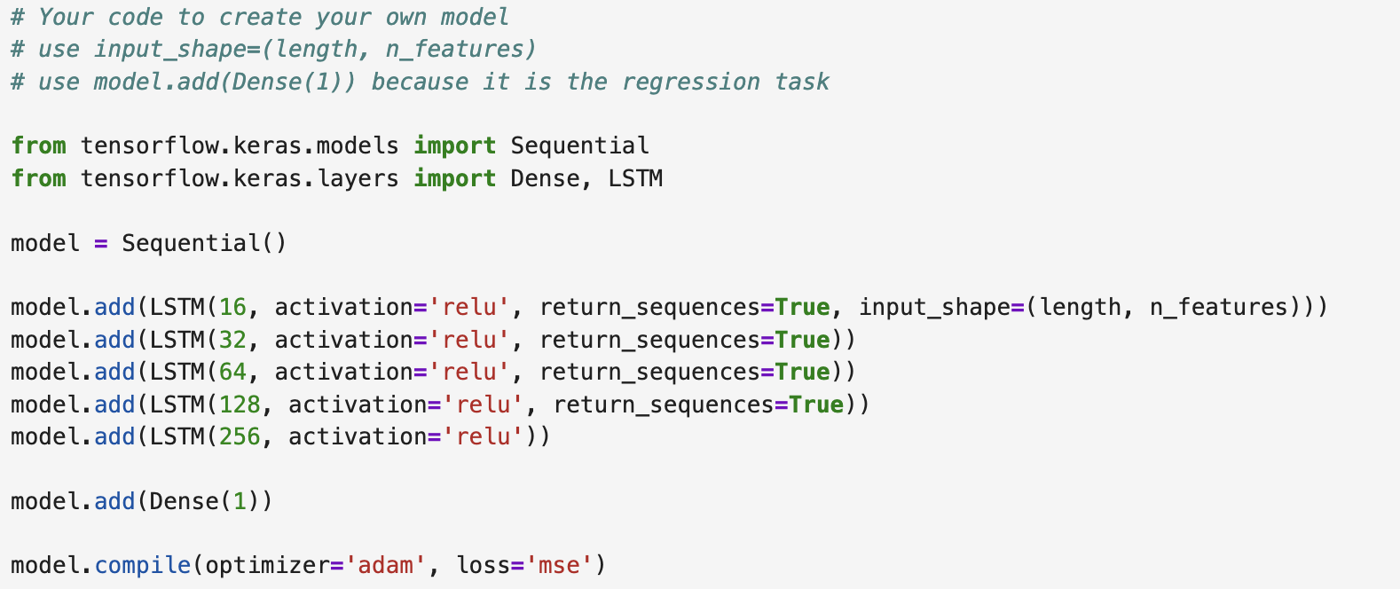

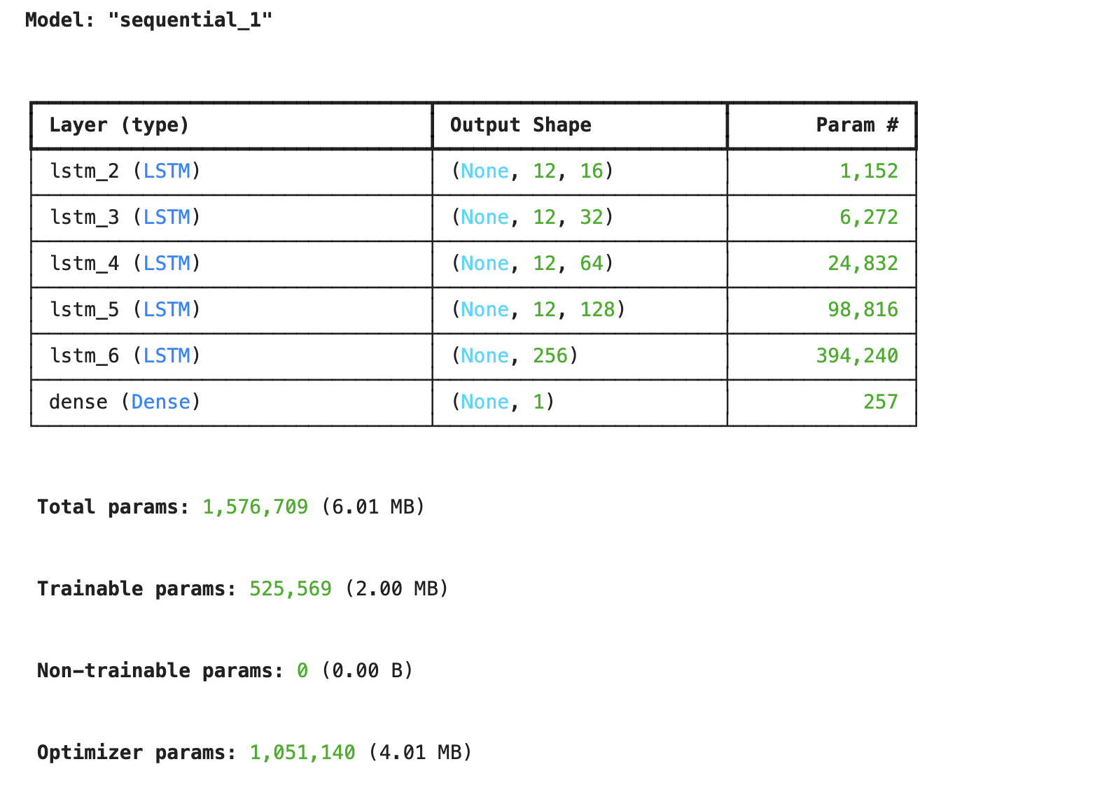
2.
early_stop = EarlyStopping(monitor='val_loss',patience=9)
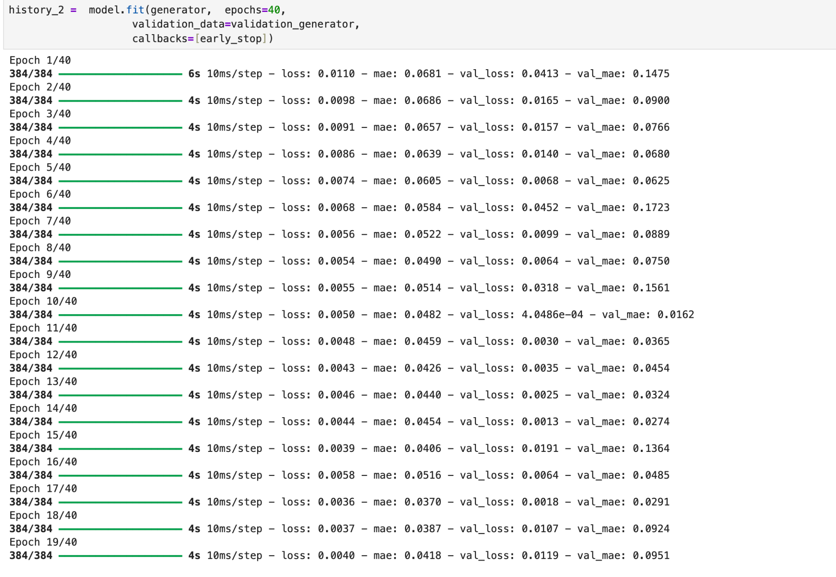
3. Plot of Validation
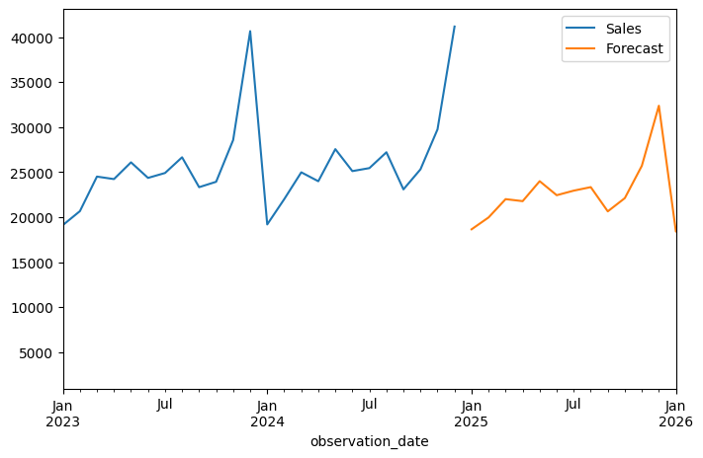
Test Loss
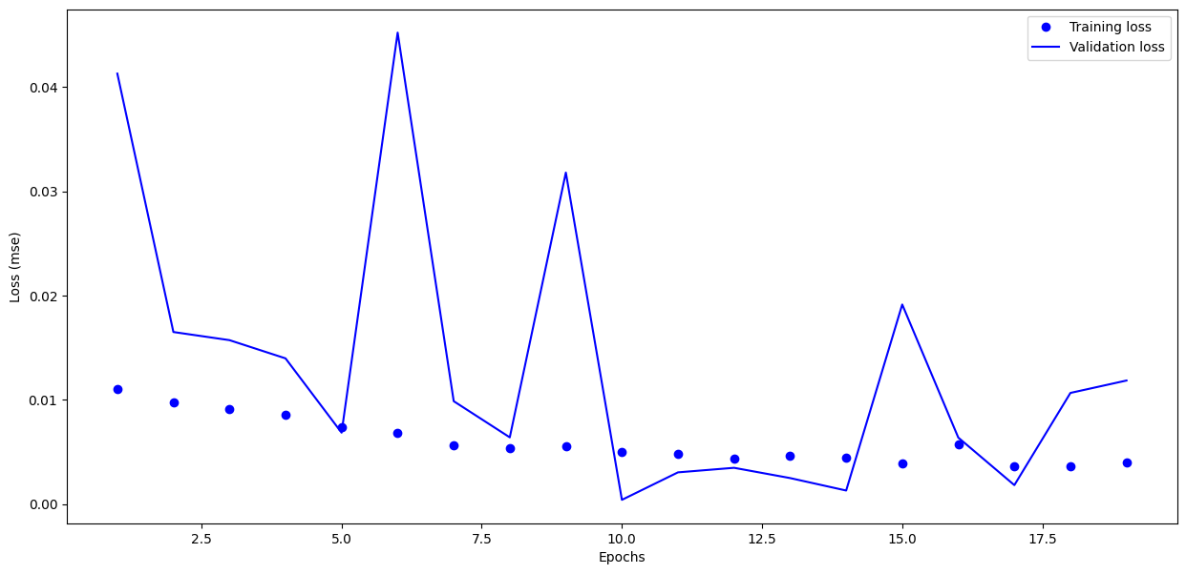
4. Optimal number of Epochs =10.
5.Plot of the Checking Forecast for the last 12 months.

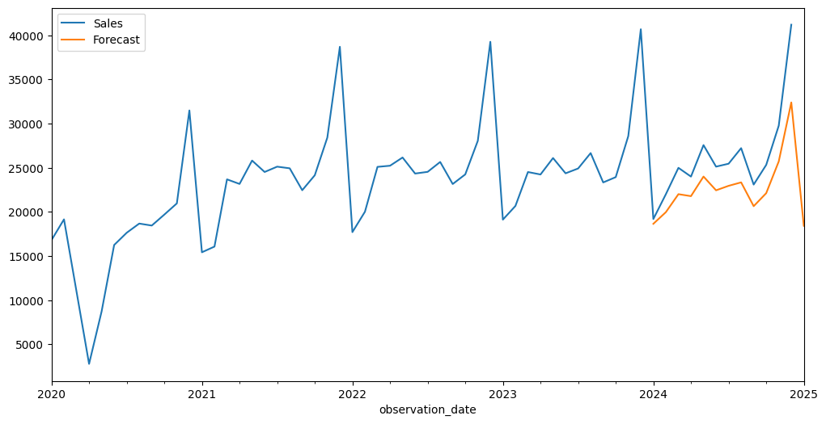
Lab 7

Lab 8

Lab 9

Lab 10

Lab 11

Lab 12

